Table of Contents

Create Point of Sale 3

View all Points of Sale 3

Set the main Point of Sale and payment methods 3

Add accounts in the Chart of Accounts 4

Add journals 4

Journal Entries - Cash1 Maadi 4

Journal Entries - Cash1 Maadi - Incoming Payments 5

Journal Entries - Cash1 Maadi - Outgoing Payments 5

Journal Entries – Cash2 Maadi 6

Journal Entries – QNB Maadi Showroom 6

Journal Entries – QNB Maadi - Incoming Payments 6

Journal Entries – QNB Maadi – Outgoing Payments 7

Define payment methods 7

Cash1 Maadi Showroom Method 7

Cash2 Maadi Showroom Method 8

Bank QNB Maadi Showroom Method 8

Receivable Maadi Showroom 9

Link payment methods to a specific POS 9

Maadi Cash1 9

Maadi Cash2 10

Link POS with inventory 12

Create Zaied warehouse 12

Create an Expenses account 12

Create a location for damaged goods 13

Edit the POS operation 13

Create a return operation 13

Edit the POS operation again 14

Edit the configurations 15

Maddi Cash1 Showroom 15

Zaied Cash1 Showroom 16

Products Categories 16

POS journals for orders and invoices 17

Assign a journal for the Order 17

Add the journal 18

Assign a journal for tax invoices and a related account in the chart of accounts 19

Create the journal 20

Create the account 20

Show receipt with each invoice using a serial number 22

Log in with Employees 23

POS Full Cycle 24

Open Register 25

Password 26

Adding Products 27

Invoice 28

Payment 29

Validate 30

# Create Point of Sale

Configuration -> pint of sale

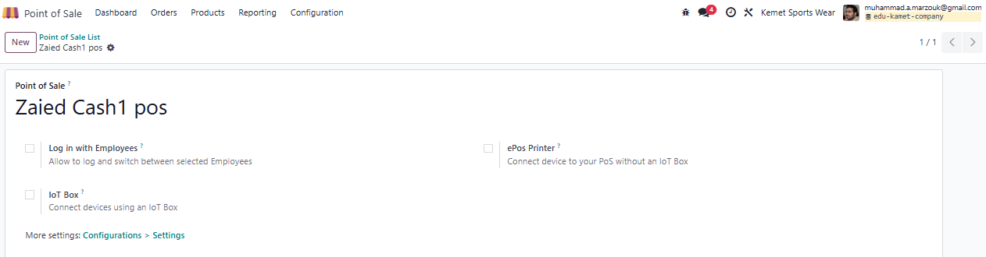

# View all Points of Sale

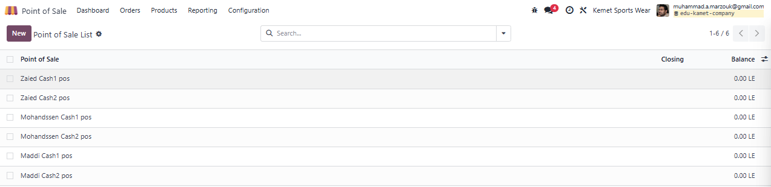After repeating the previous step, the POS List will look like this

# Set the main Point of Sale and payment methods

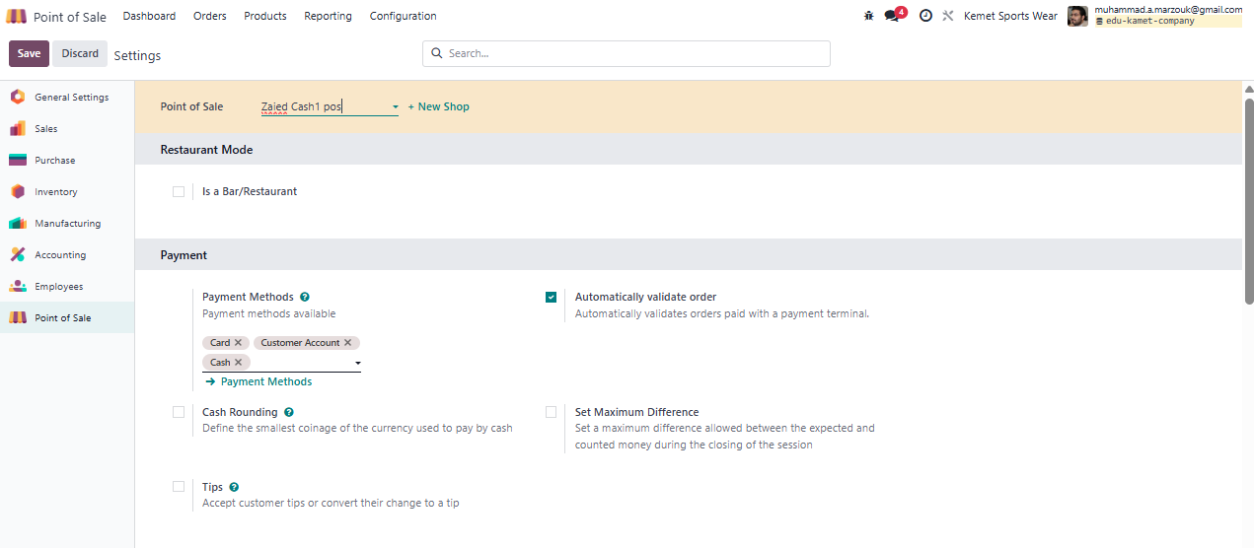

# Add accounts in the Chart of Accounts

# Add journals

## Journal Entries - Cash1 Maadi

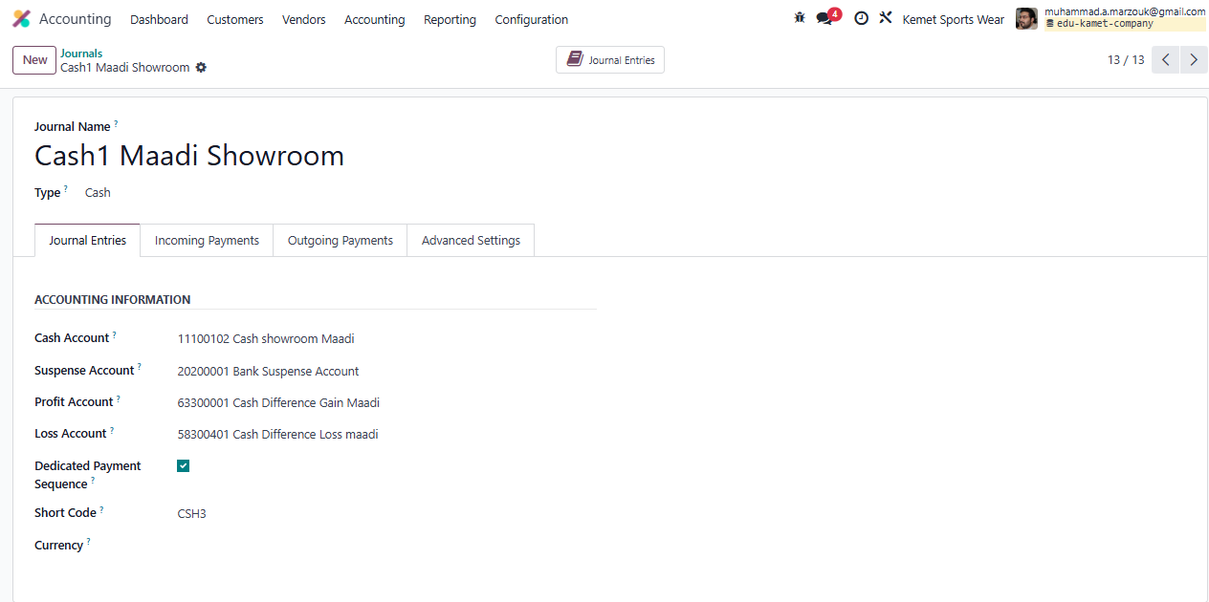

### 

### Journal Entries - Cash1 Maadi - Incoming Payments

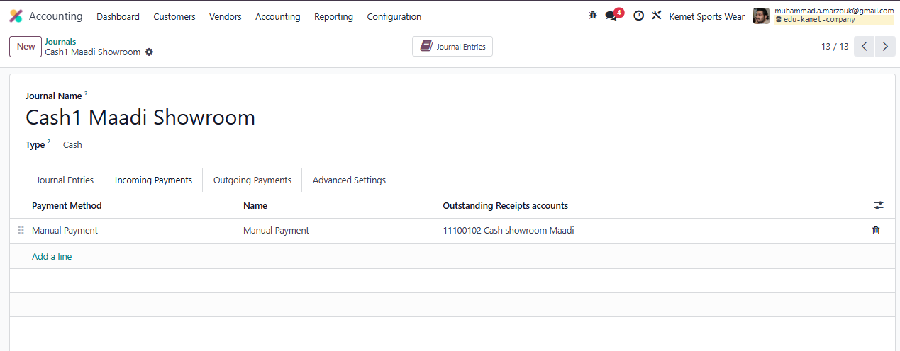

### Journal Entries - Cash1 Maadi - Outgoing Payments

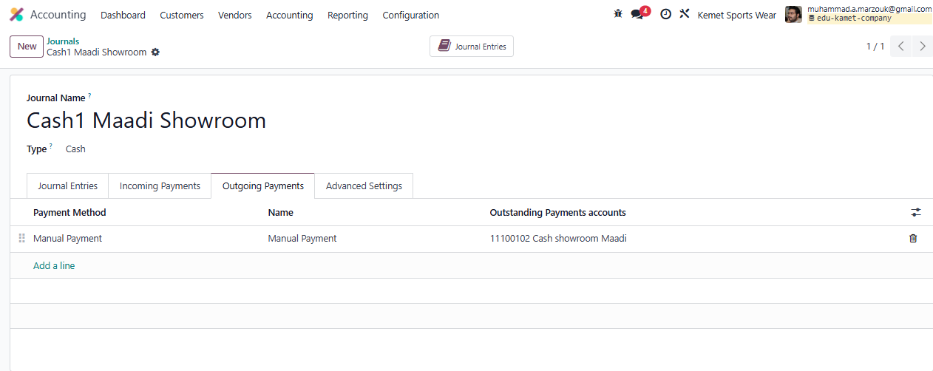

## Journal Entries – Cash2 Maadi

Same steps as cash1, just change the name and keep all accounts the same.

## Journal Entries – QNB Maadi Showroom

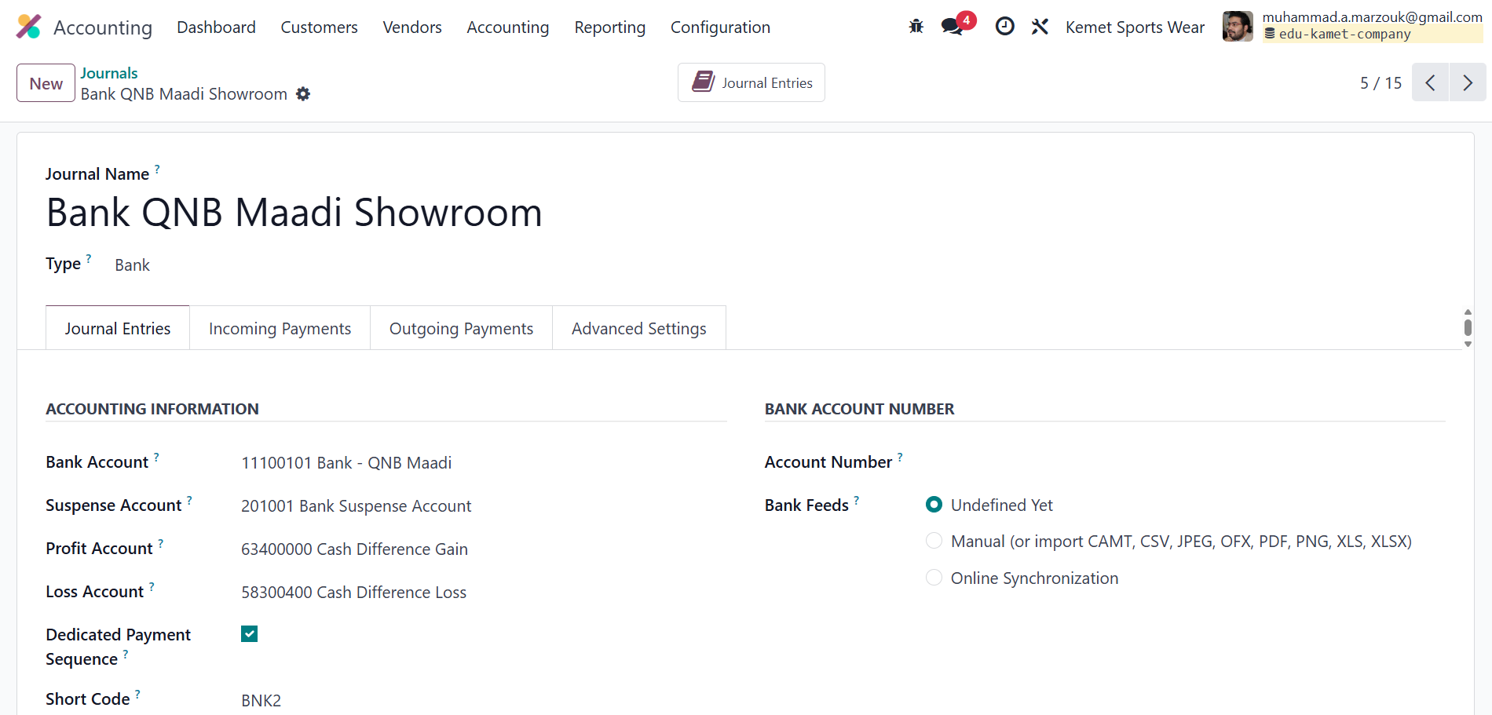

### Journal Entries – QNB Maadi - Incoming Payments

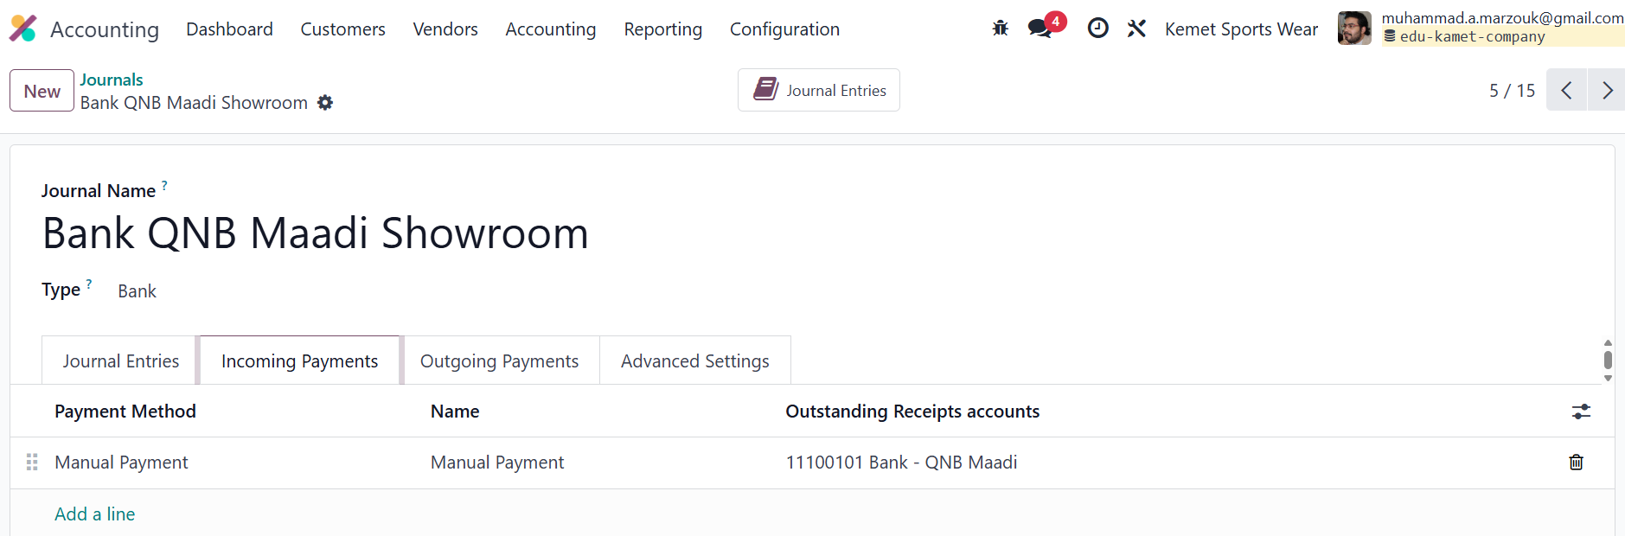

### 

### Journal Entries – QNB Maadi – Outgoing Payments

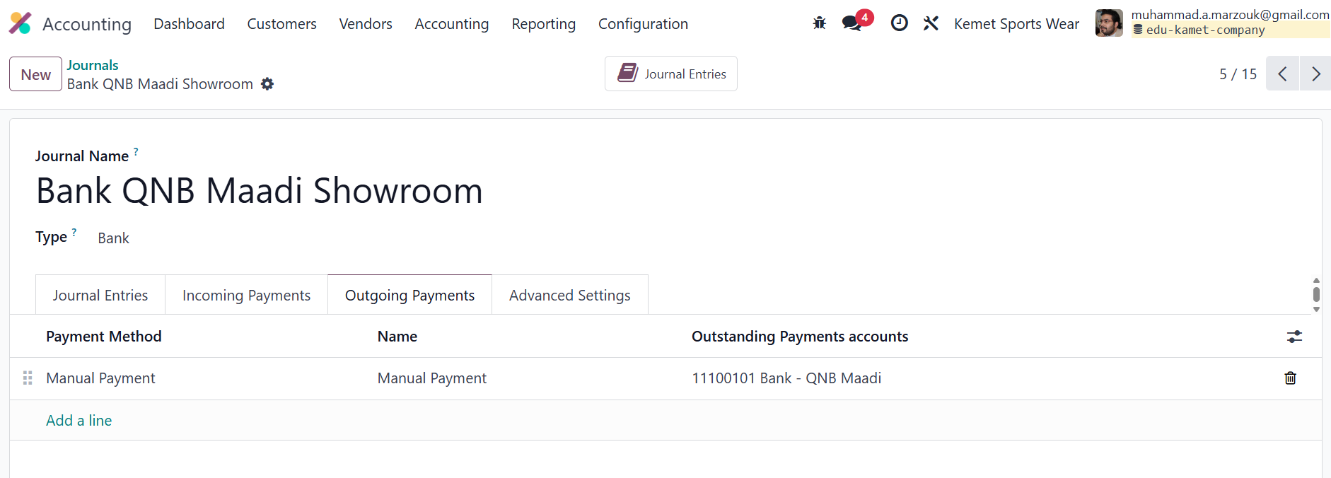

One bank account serves more than one cash drawer.

You may find a Fawry machine in the branch for anyone wanting to pay by Visa.

Even if there are multiple machines, all are linked to one bank account only.

Incoming and Outgoing Payments are for direct impact on the cash without account reconciliation.

# Define payment methods

Configuration -> Payment Methods

## Cash1 Maadi Showroom Method

Set a cash payment method for the first cashier

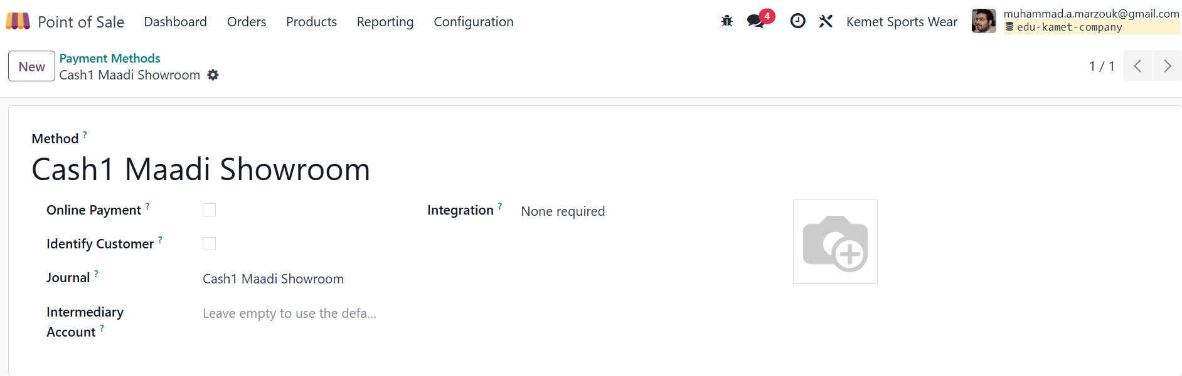

## Cash2 Maadi Showroom Method

Set a cash payment method for the second cashier

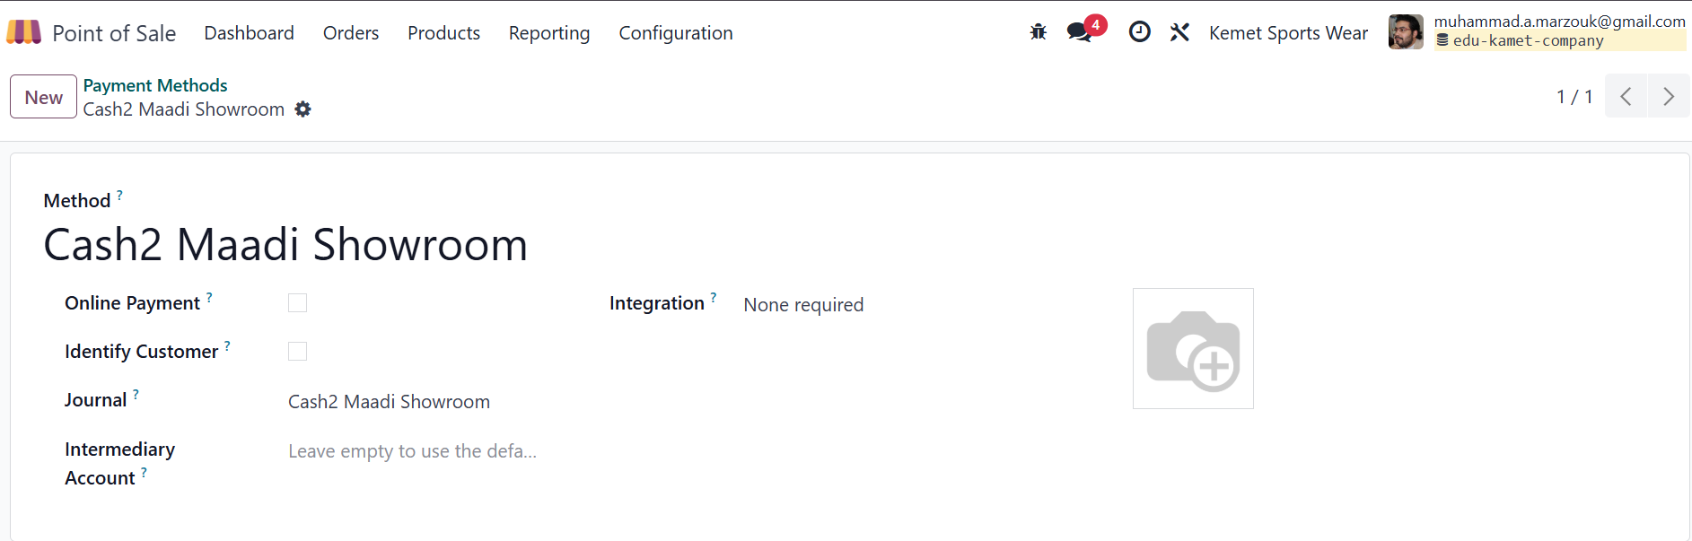

## Bank QNB Maadi Showroom Method

Payment method for the whole branch via Visa

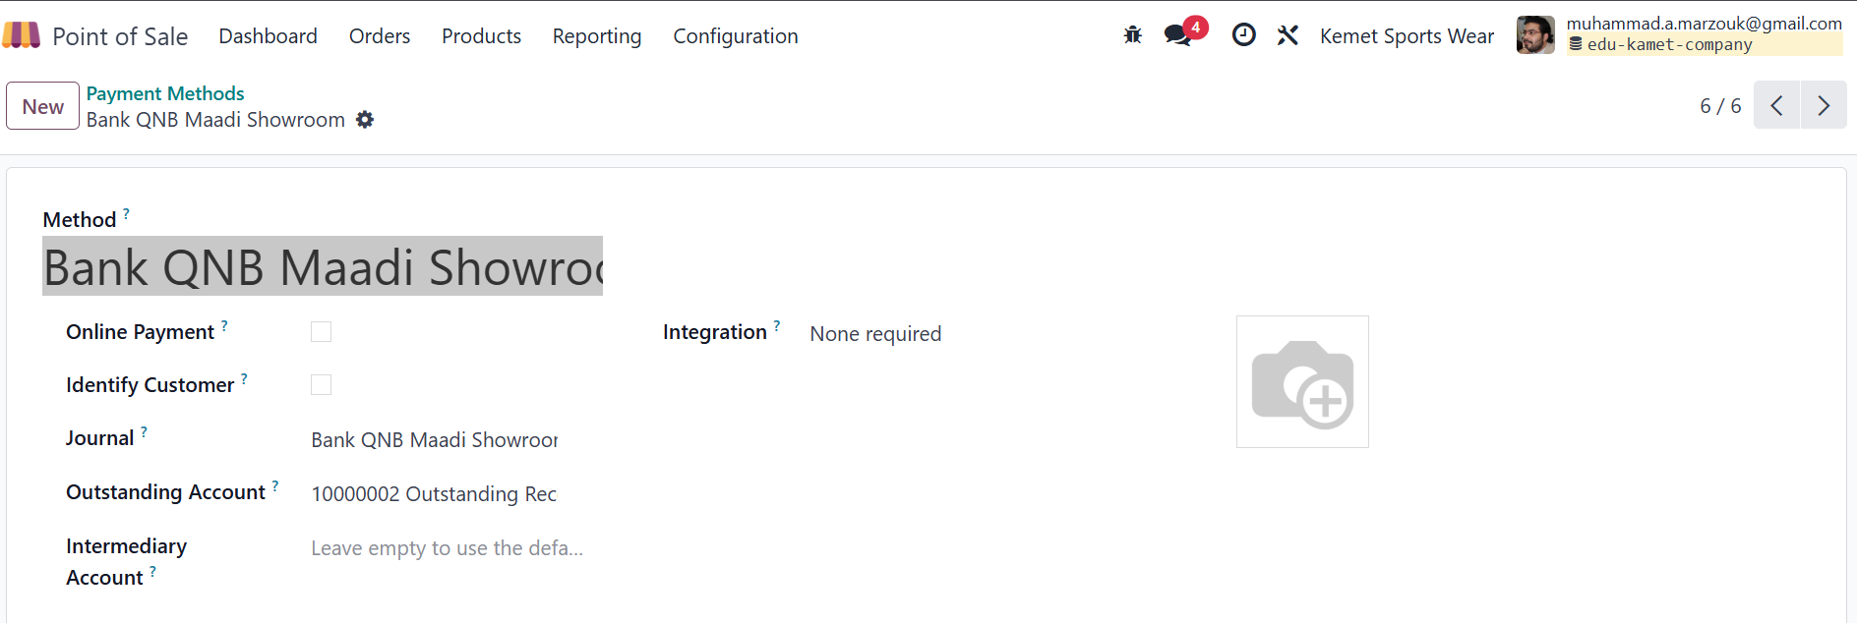

## Receivable Maadi Showroom

Postpaid sales method for a company client

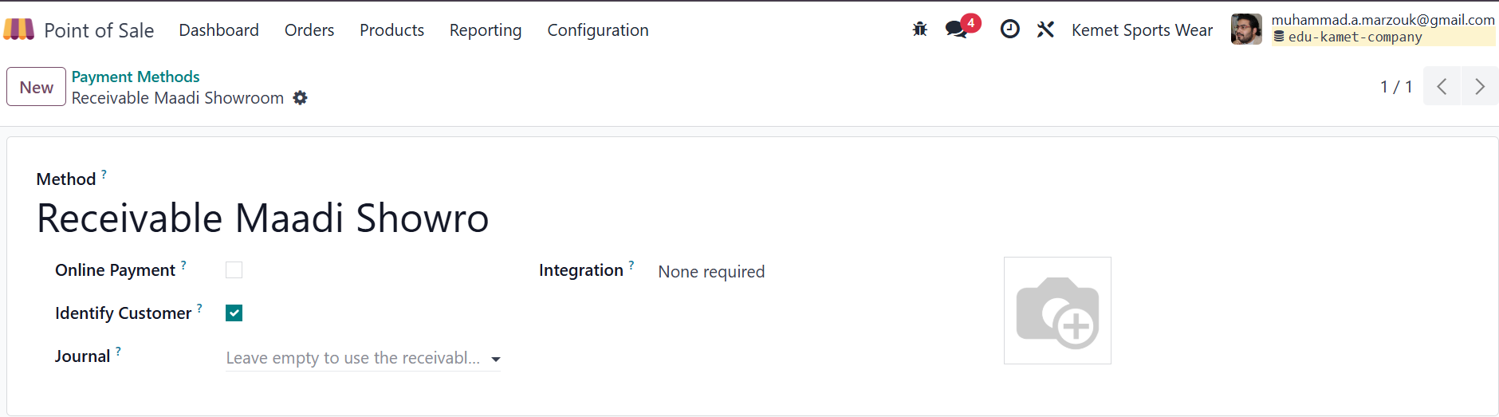

# Link payment methods to a specific POS

## Maadi Cash1

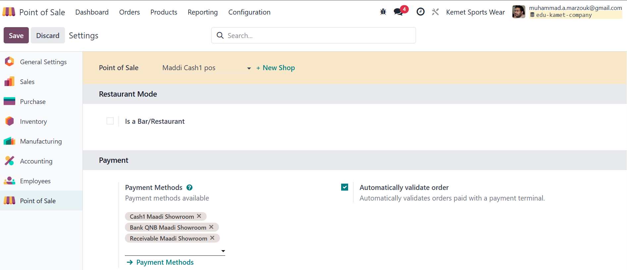

## Maadi Cash2

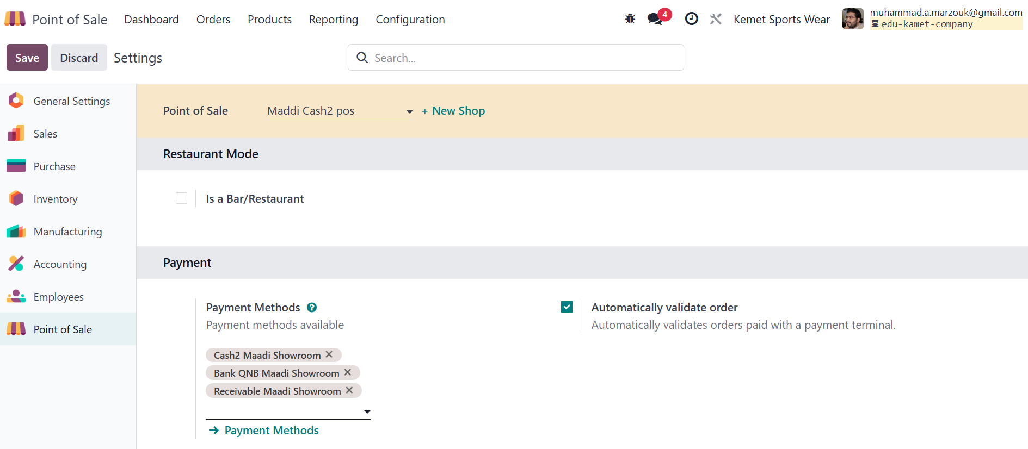

After finishing, the payment methods will appear like this

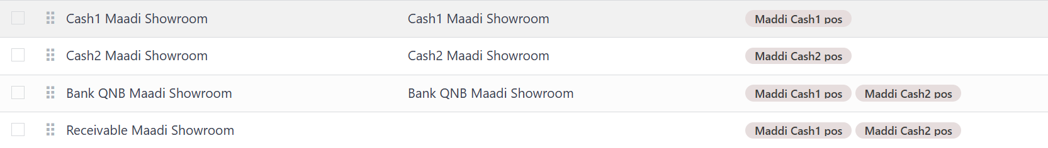

Repeat the same steps for journals and payment methods to add Sheikh Zayed branch methods.

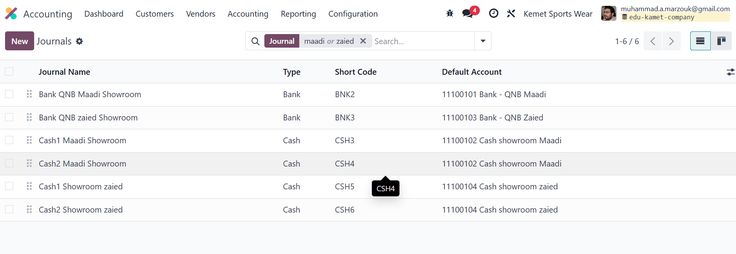So the journal will appear like this:

And the Payment Methods will appear like this after linking POS to payment methods from settings

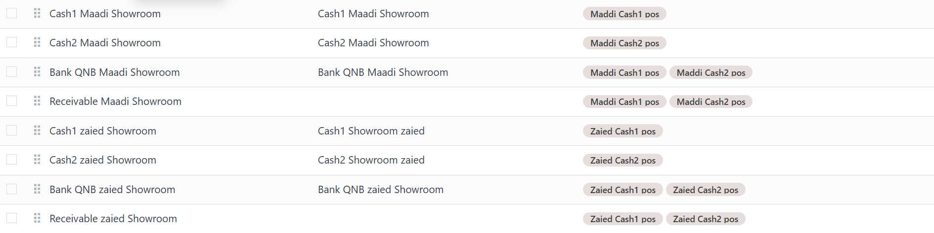

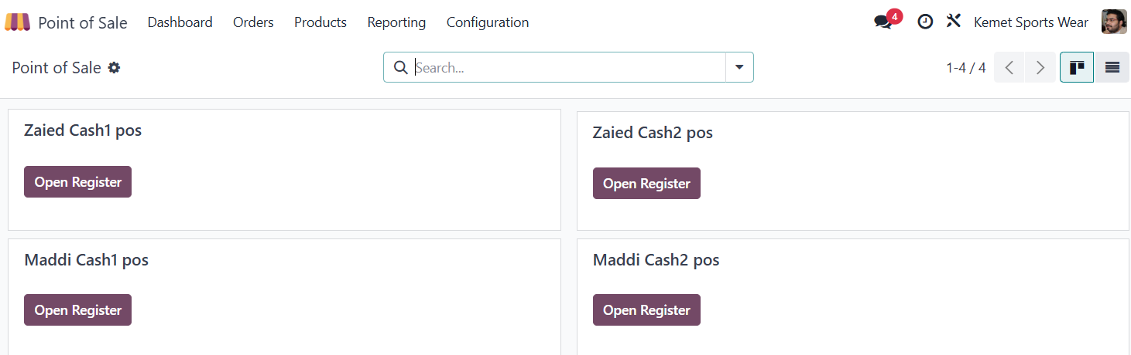The dashboard will appear like this:

This completes step one successfully

# Link POS with inventory

Create one warehouse per showroom

## Create Zaied warehouse

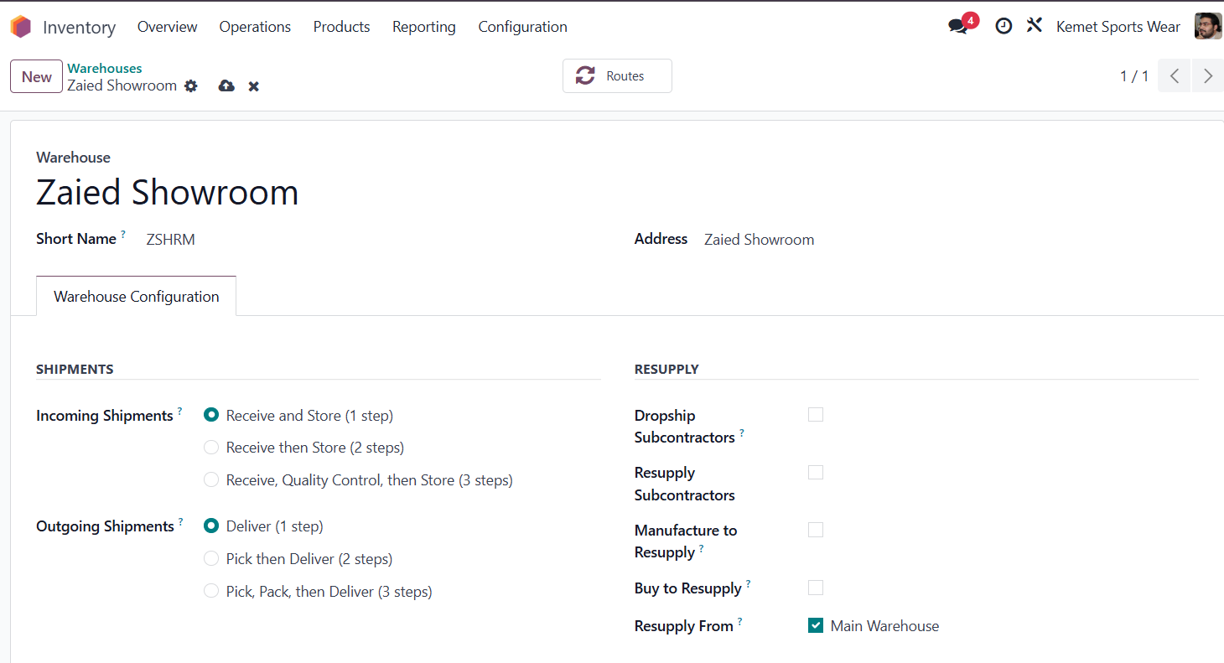

The warehouse doesn't issue goods in any purchase operations , so stock is only transferred from the main warehouse.

## Create an Expenses account

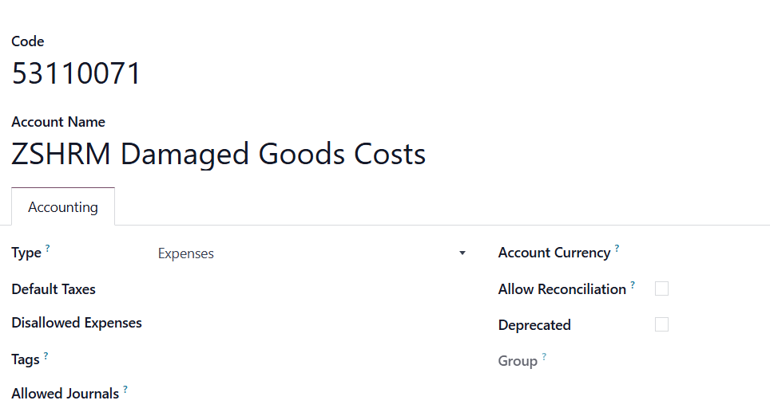

## Create a location for damaged goods

## Edit the POS operation

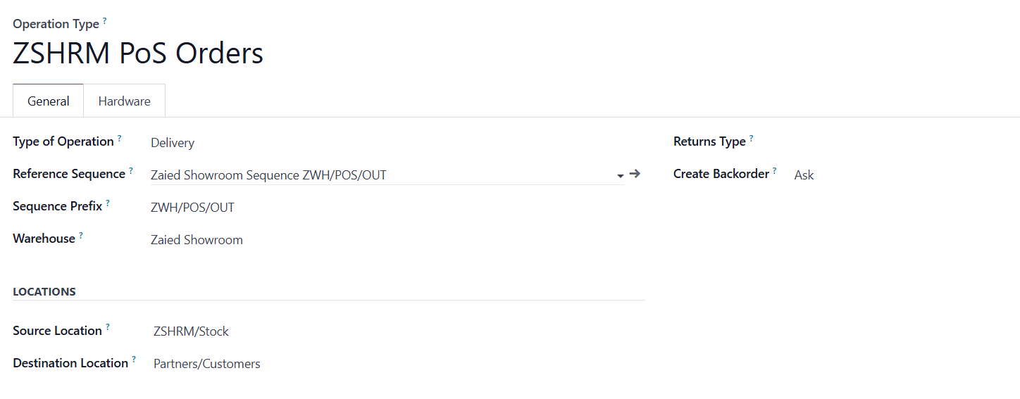

## Create a return operation

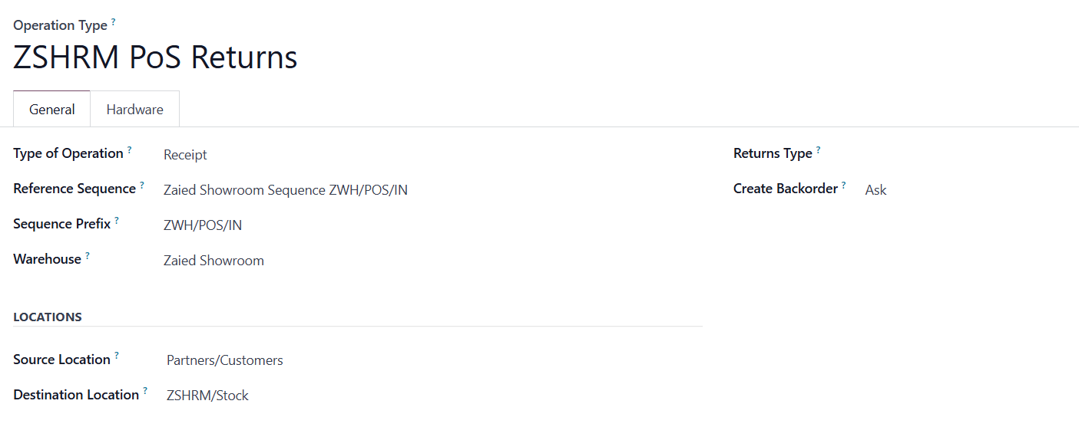

## Edit the POS operation again

To define return policy

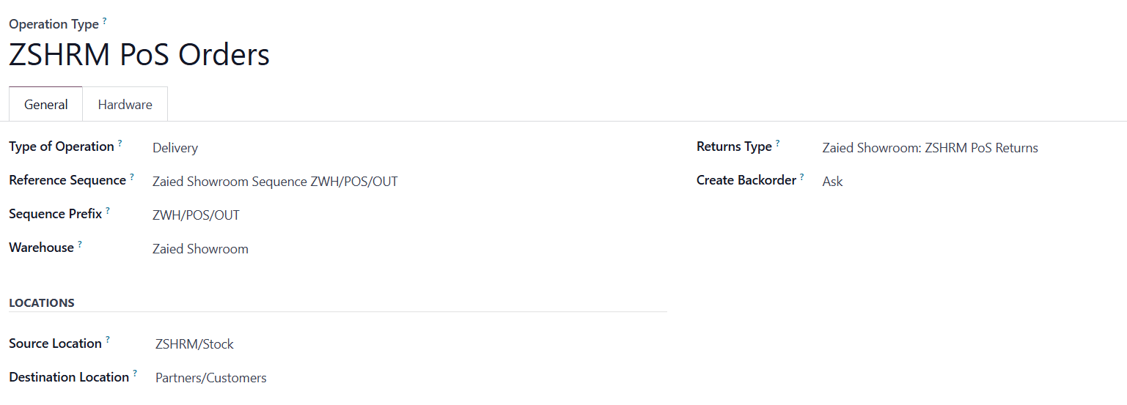

So all operations look like this:

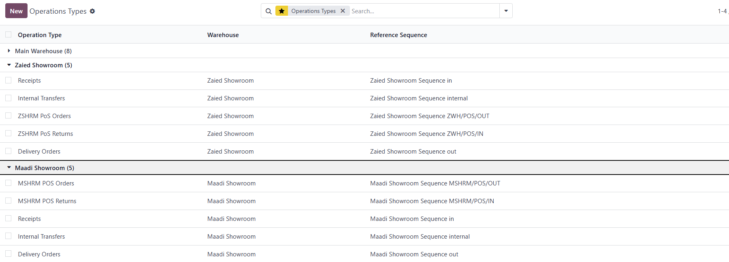

You can archive other operations to hide them from Inventory Overview.

Inventory Overview will look like this:

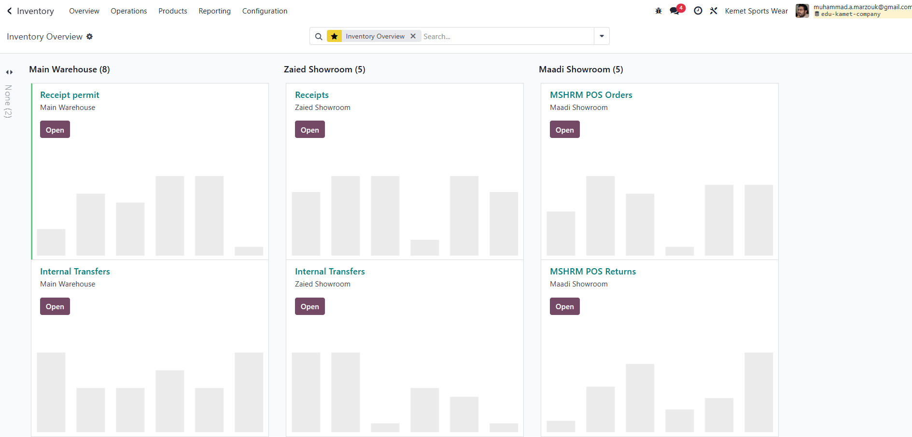

## Edit the configurations

For each POS related to Inventory.

### Maddi Cash1 Showroom

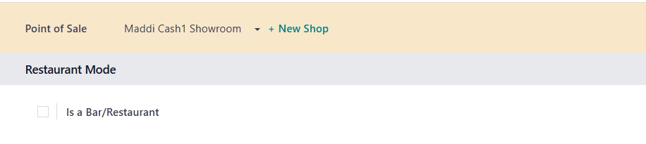 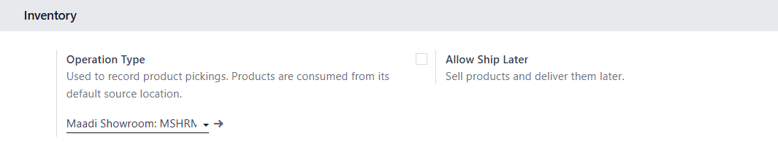

Same for Maddi Cash2 Showroom, will take the same operation

### Zaied Cash1 Showroom

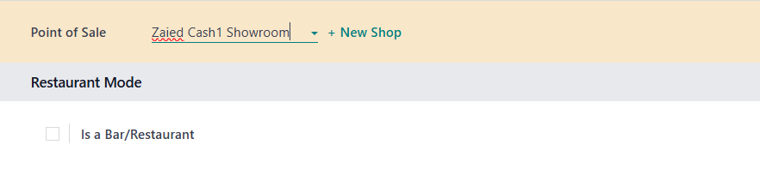

Same for Zaied Cash2 Showroom, will take the same operation.

# Products Categories

A tool provided by Odoo to display POS products on the POS screen.

Configuration -> PoS Product Category

Classify sellable products within POS

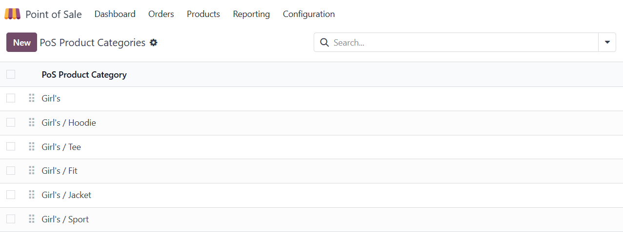

Product settings from inventory to display in POS

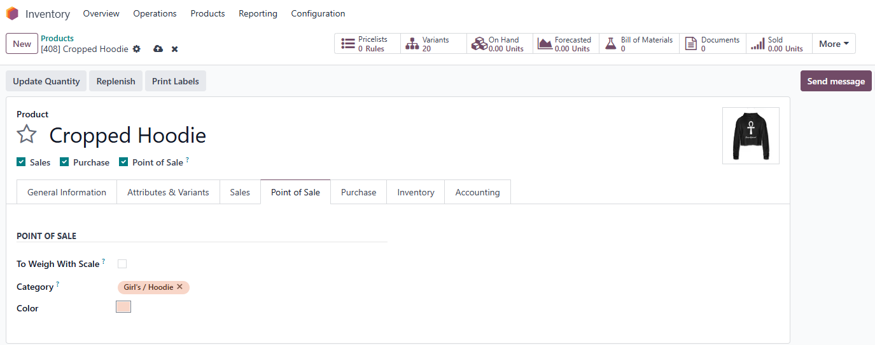

# POS journals for orders and invoices

## Assign a journal for the Order

Assign a journal for all orders from Maadi branch,

Maddi Cash1 Showroom and Maddi Cash2 Showroom

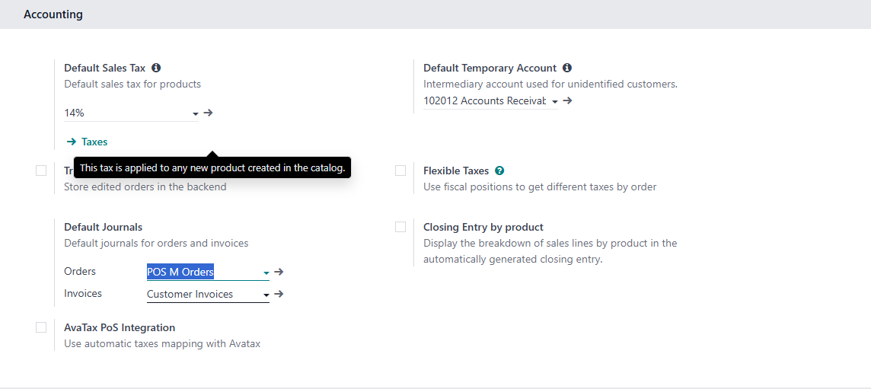

### Add the journal

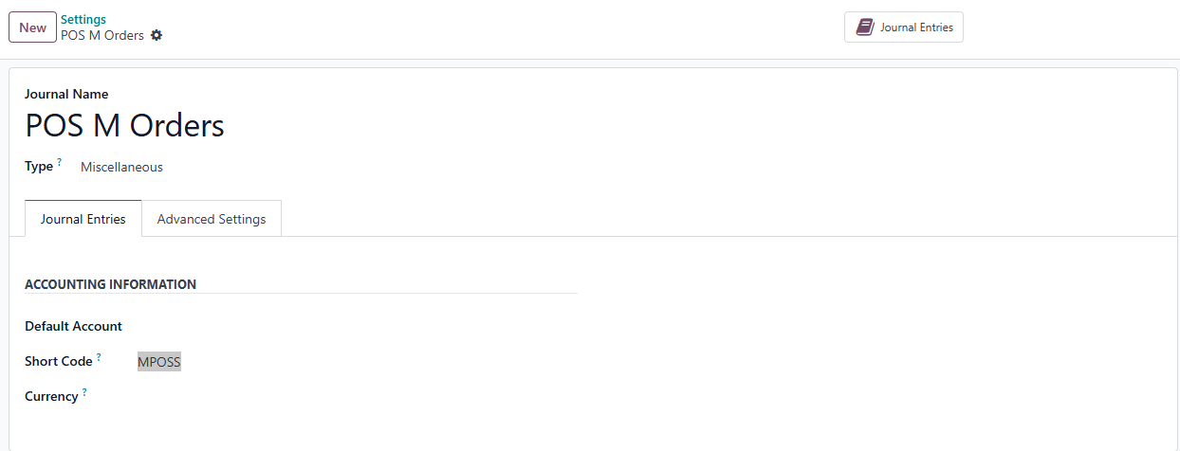

And Zaied Cash1 Showroom Choose Zaied Cash2 Showroom

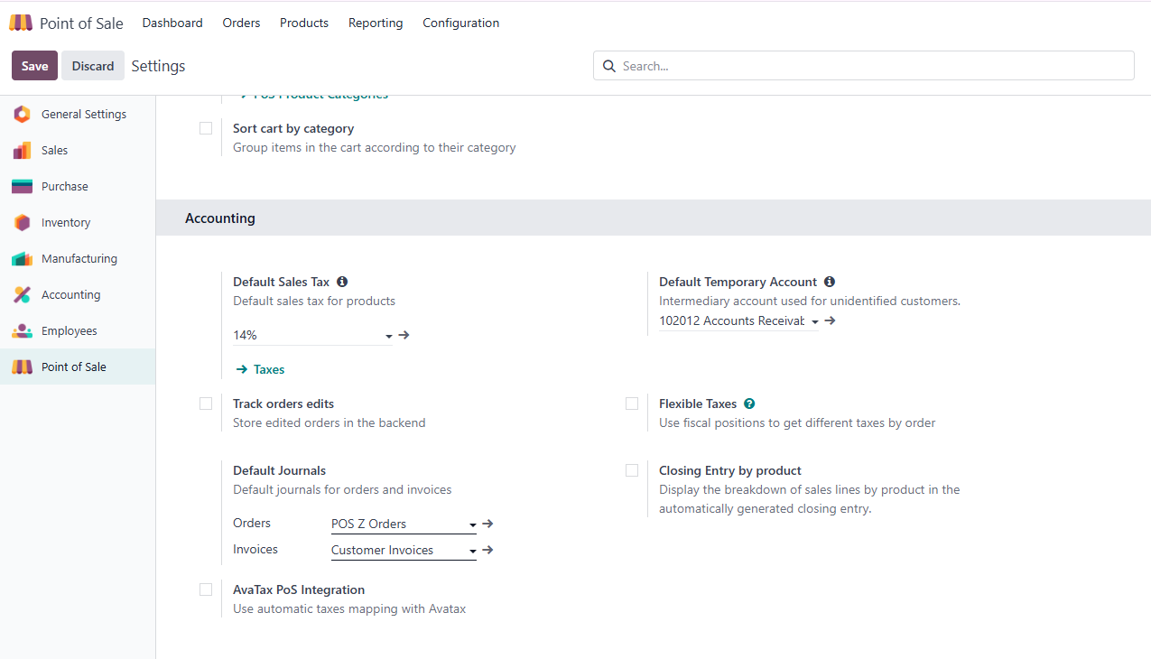

Add the journal

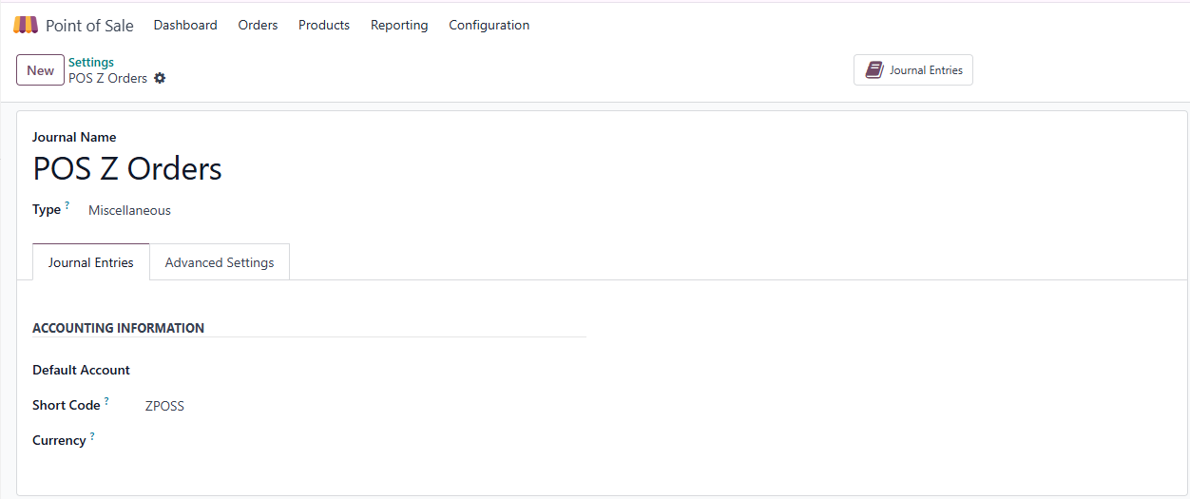

## Assign a journal for tax invoices and a related account in the chart of accounts

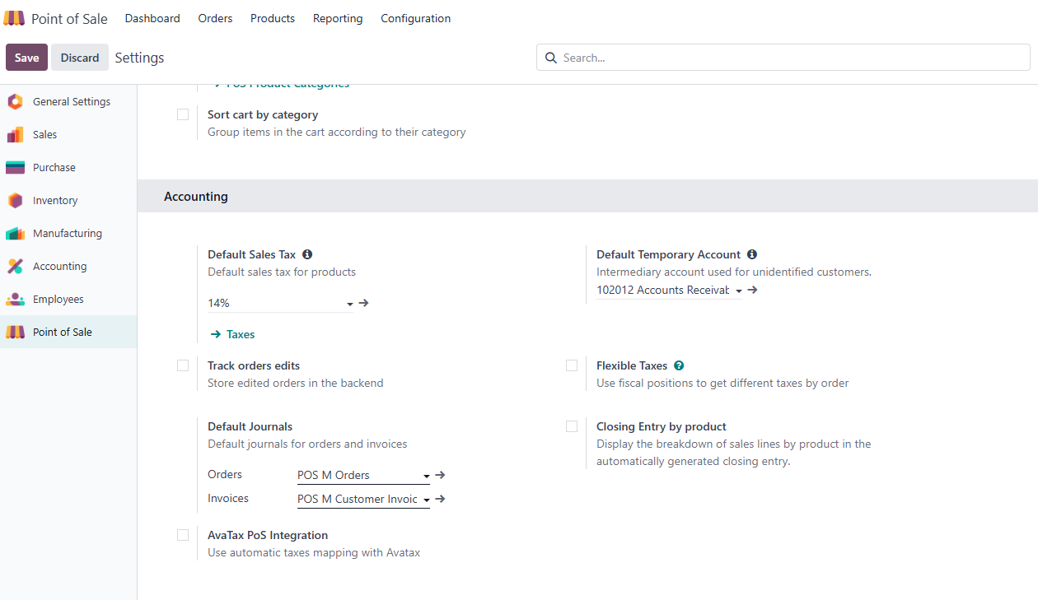Maddi Cash1 Showroom Choose Maddi Cash2 Showroom and

### Create the journal

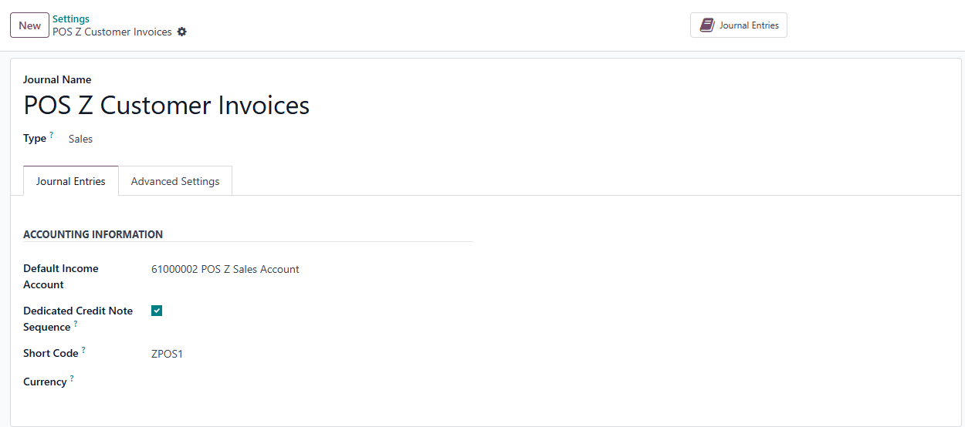

### Create the account

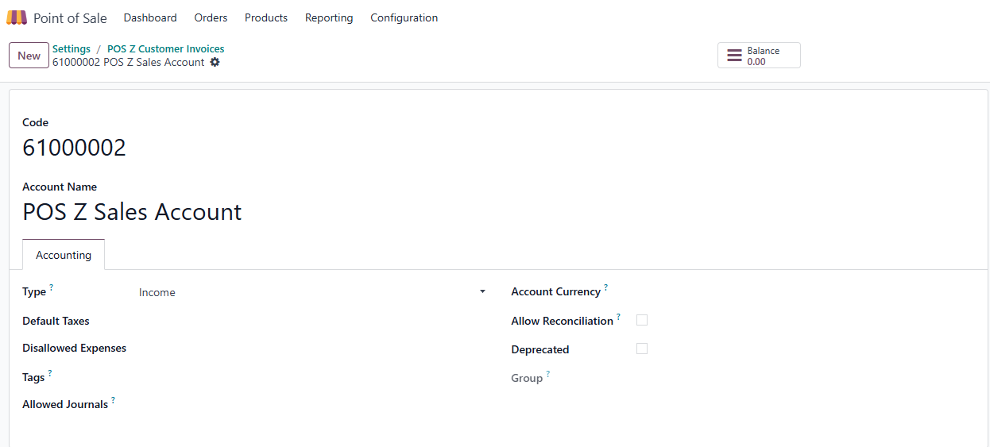

Create the journal for Zaied Cash1 Showroom and Zaied Cash2 Showroom

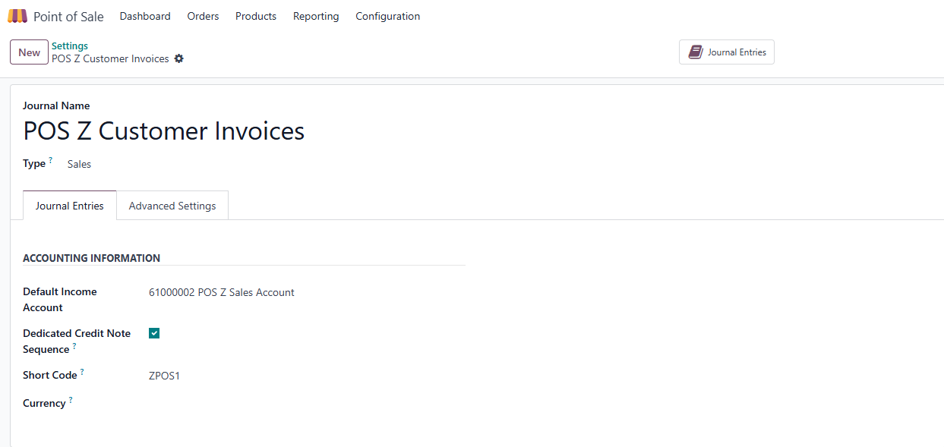

Create the account

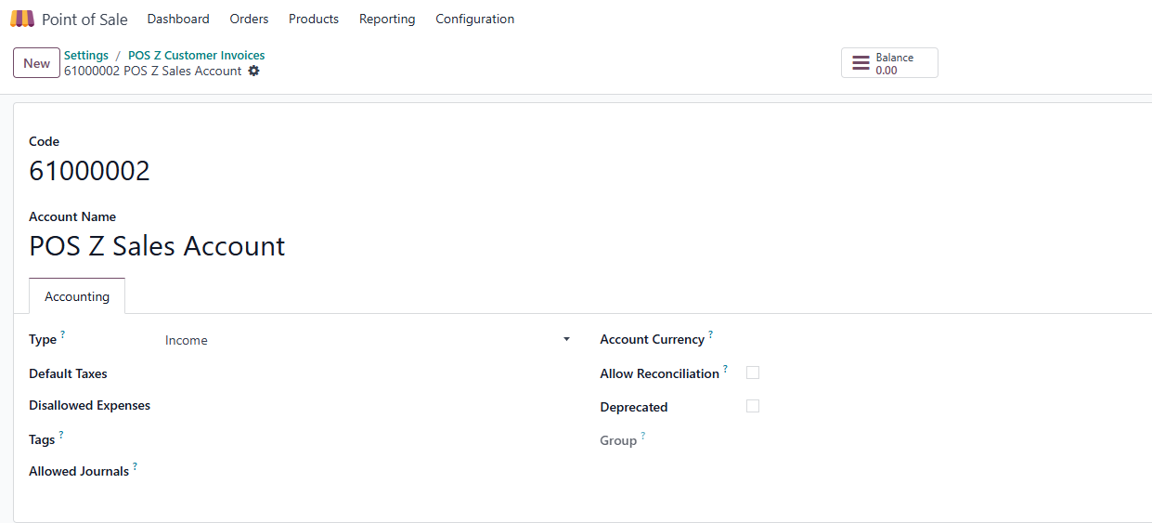

# Show receipt with each invoice using a serial number

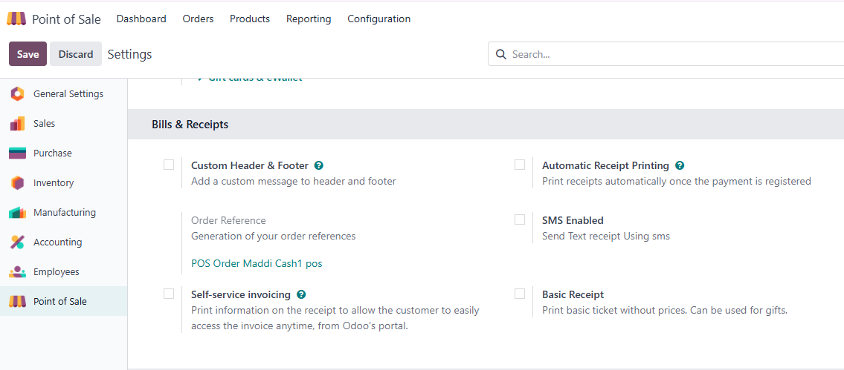

Order Reference format to edit

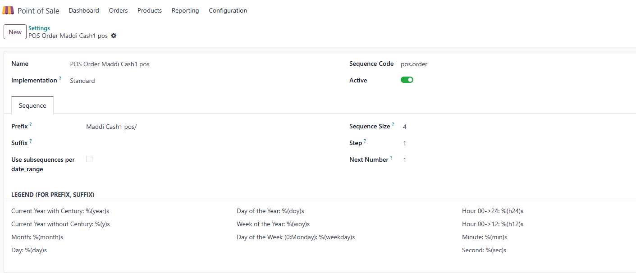

# Log in with Employees

POS login permissions

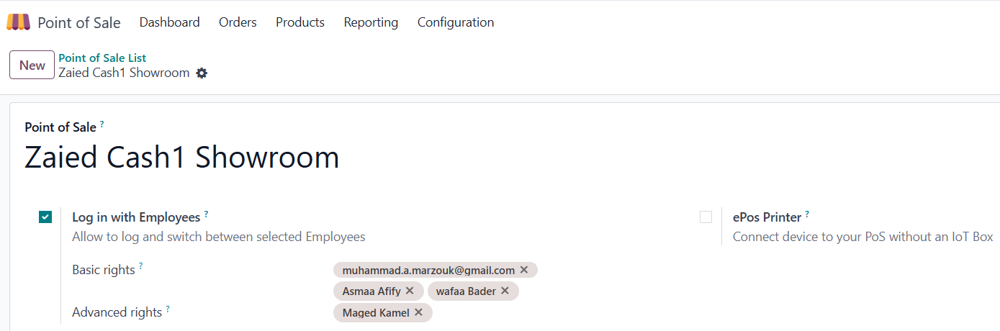

Set the PIN for each employee (cashier)

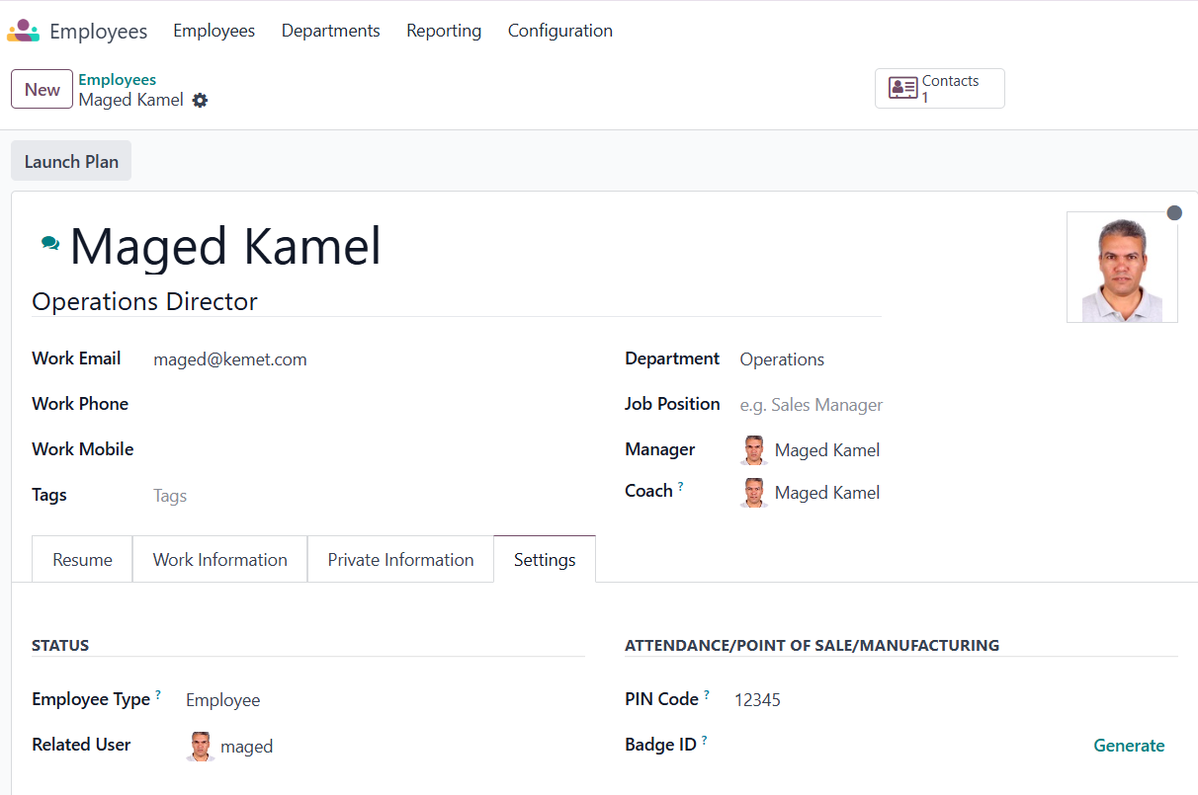

# POS Full Cycle

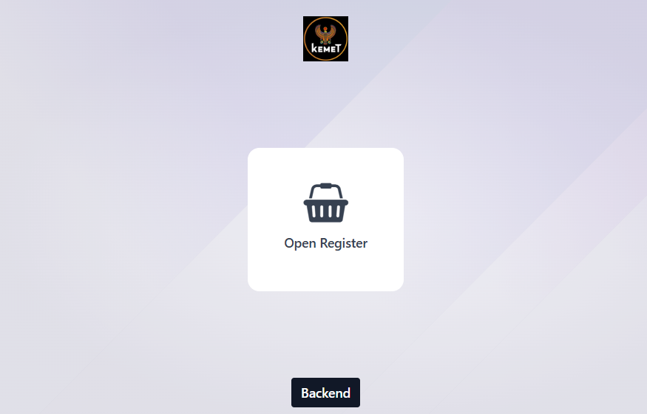

## Open Register

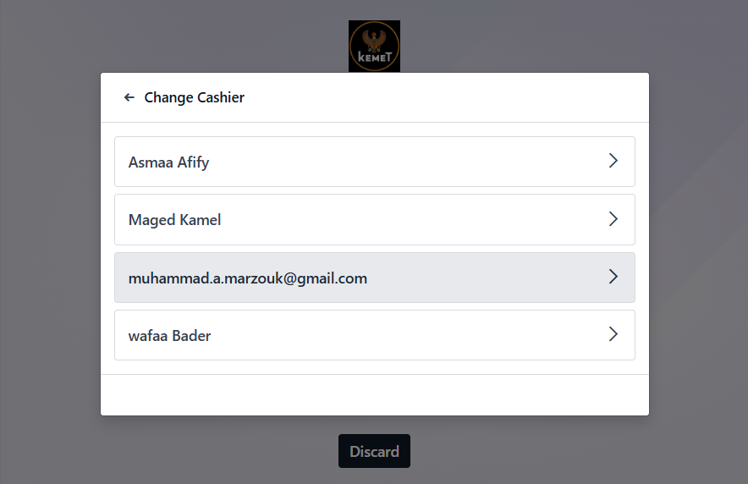

## Password

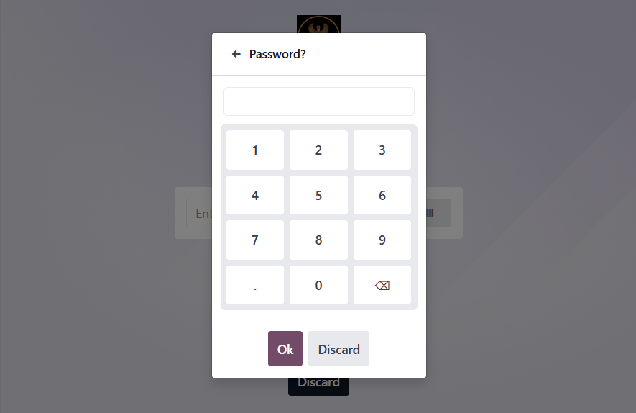

Opening Control

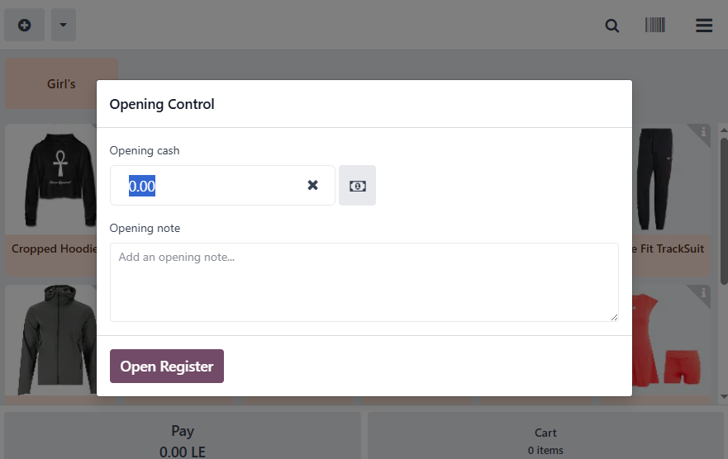

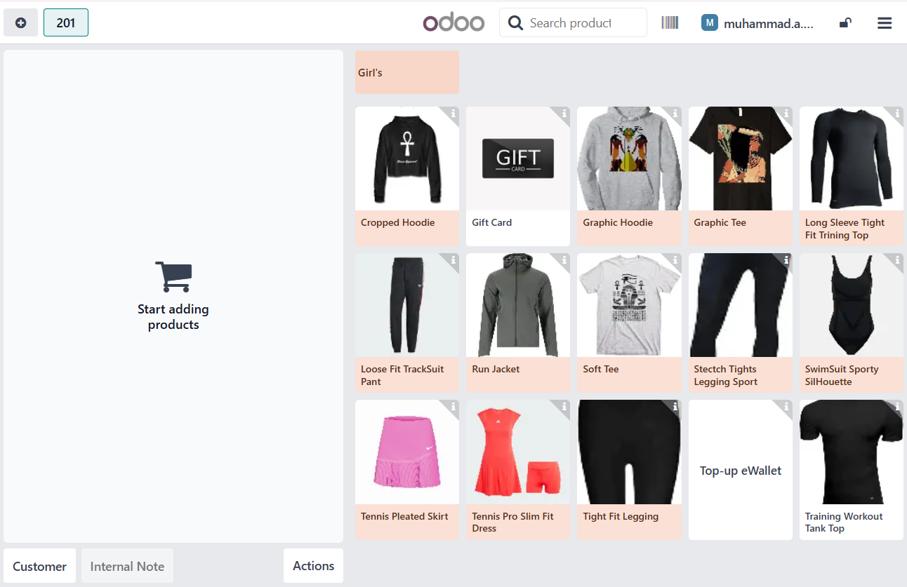

## Adding Products

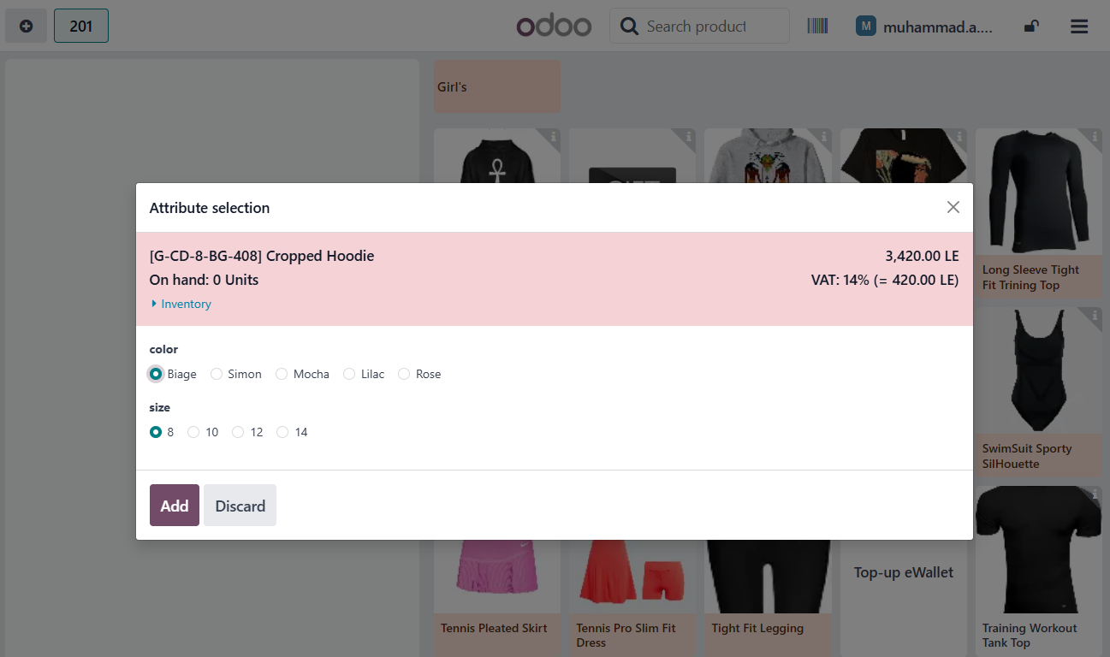

## Invoice

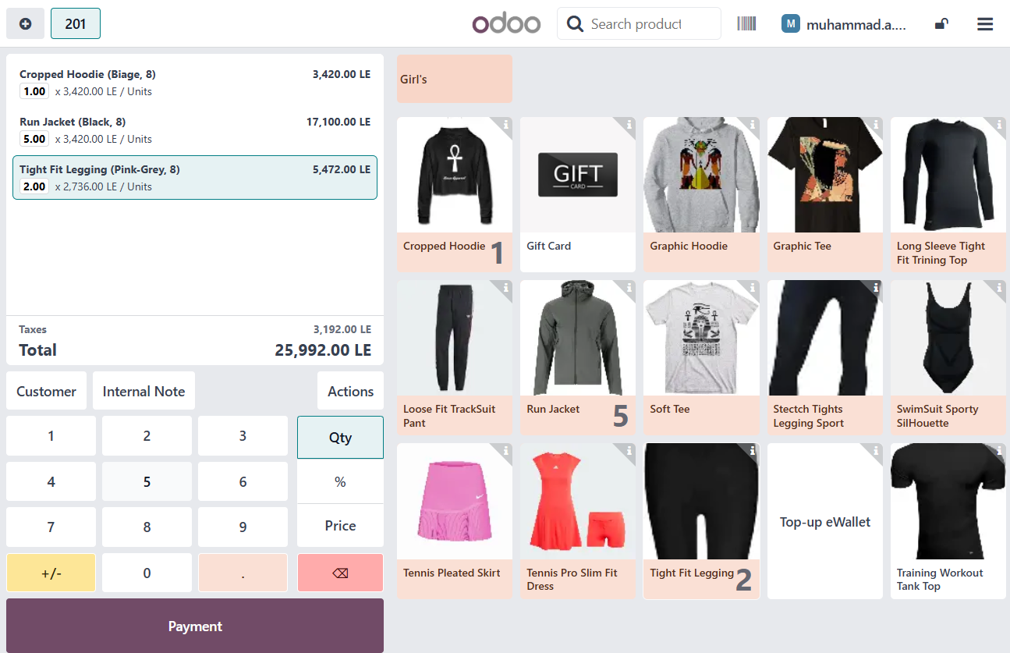

## Payment

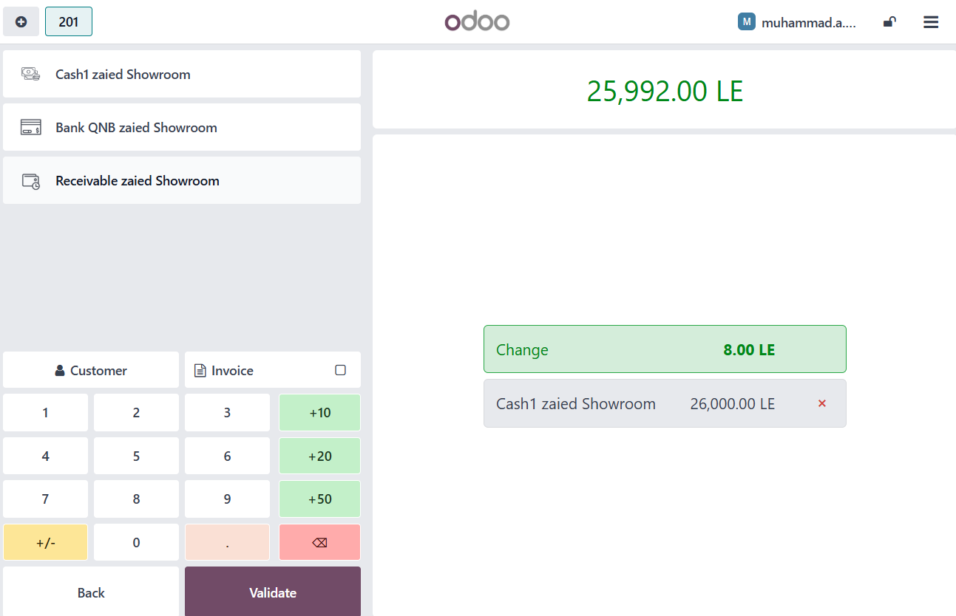

## Validate

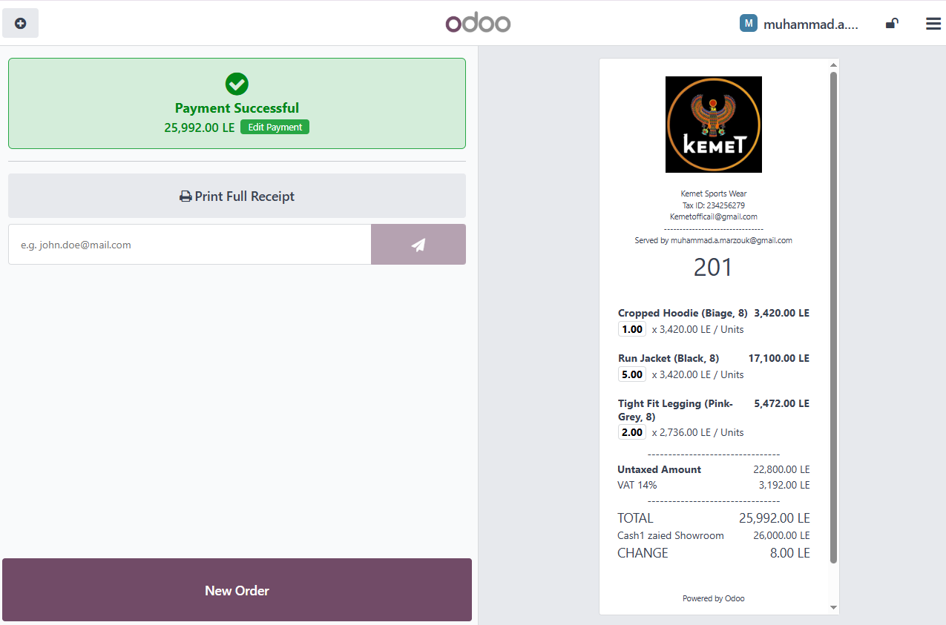

Closing Register

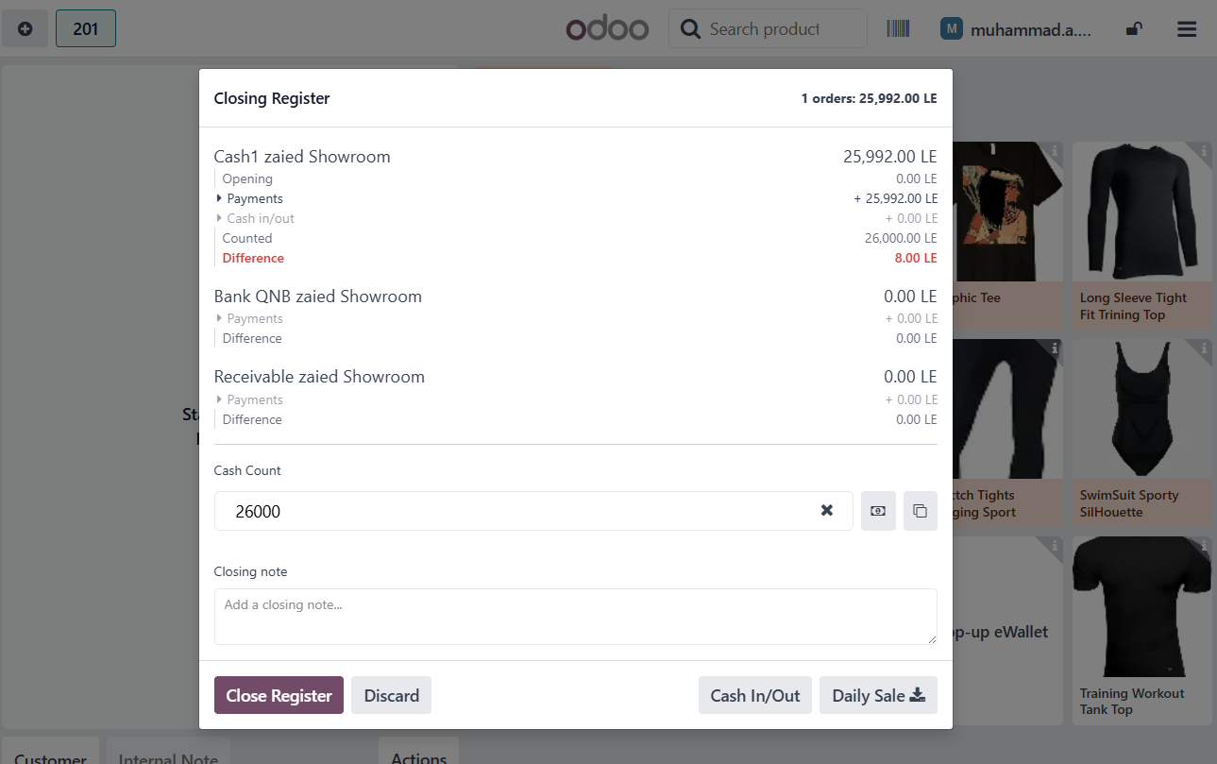

Payments Different

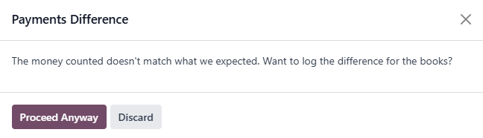

Invoice from two Cashiers

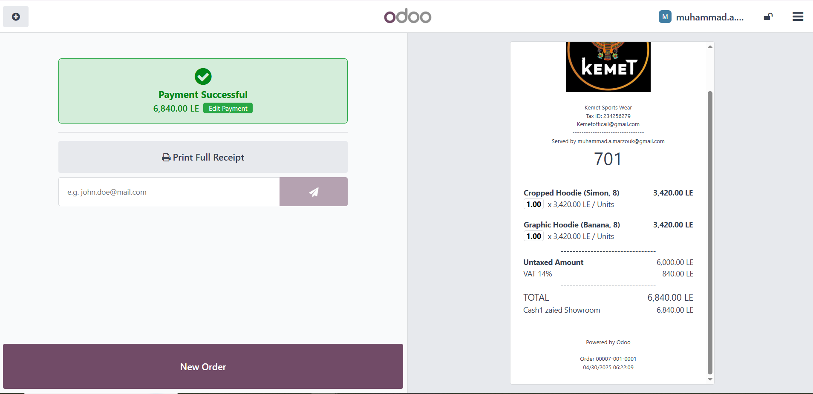

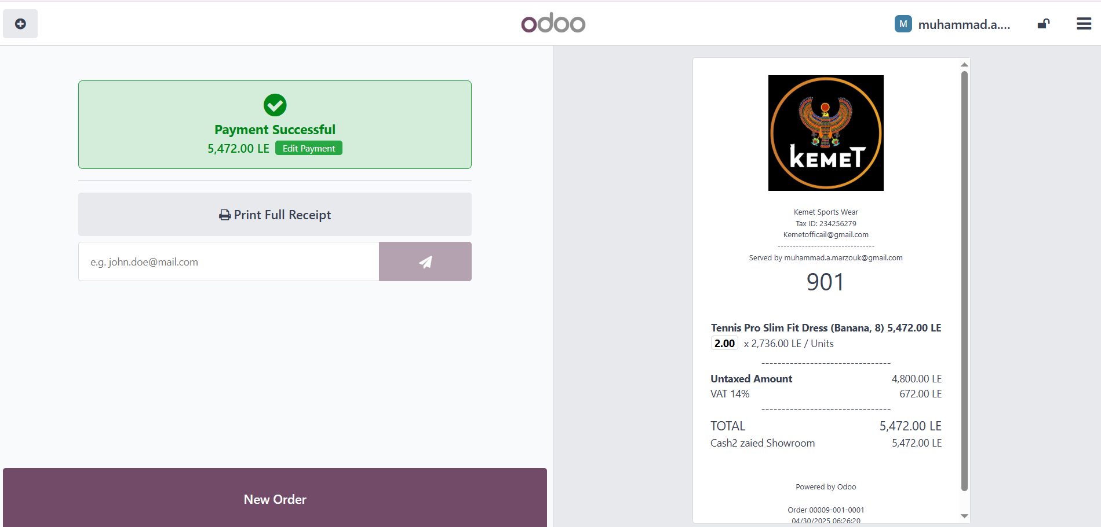

**Pro Sync integrated Solutions** **Kemet Sportswear Co.**

**Technical Manager**  **Project Manager**

Mr. Mohamed Marzouk MR. Atef Ibrahim